How to Convert an Excel file To CSV format.

1. **Press Ctl + R on a Windows Machine and type control panel and Press Enter.**

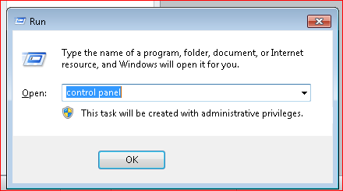

**Alternatively, Go to Windows Start Button and select Control Panel .**

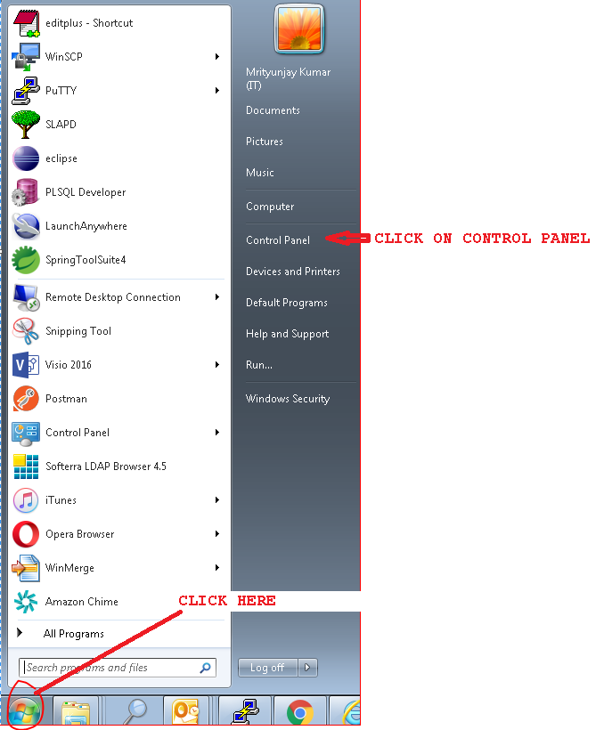

1. **Select Region and Language**

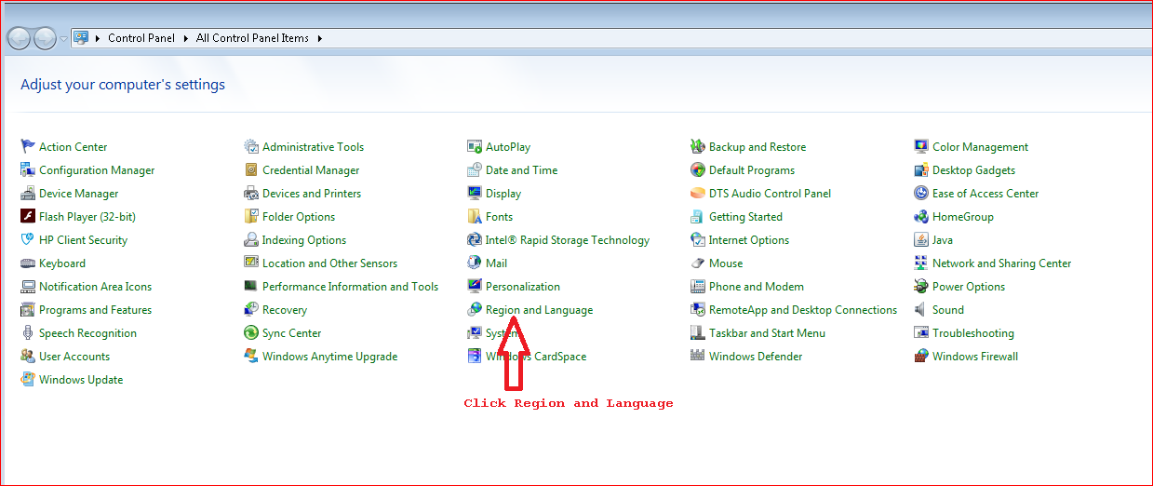

1. **Click Additional setting**

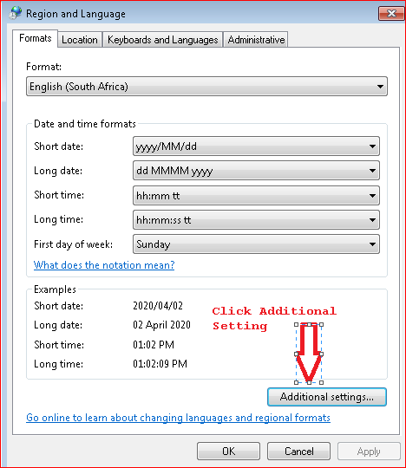

1. **Change the Coma to pipe in Line separator field**

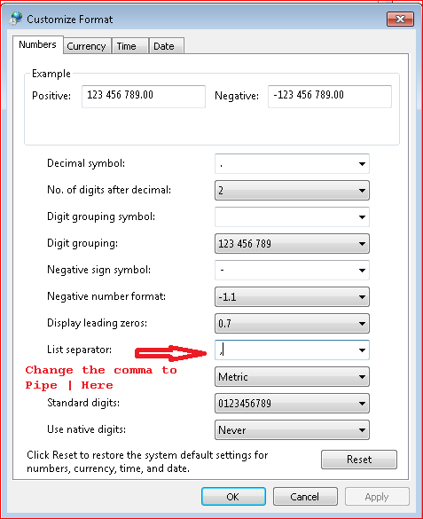

**Once comma is changed to Pipe, click Apply button and then OK button.**

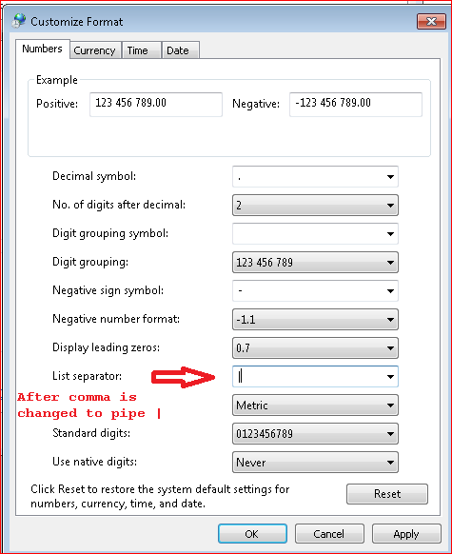

1. **Open the Excel file which has all employee information. Check * for all mandatory fields. Complete all mandatory Fields for successful Loading. Failure will result in No Payment.**

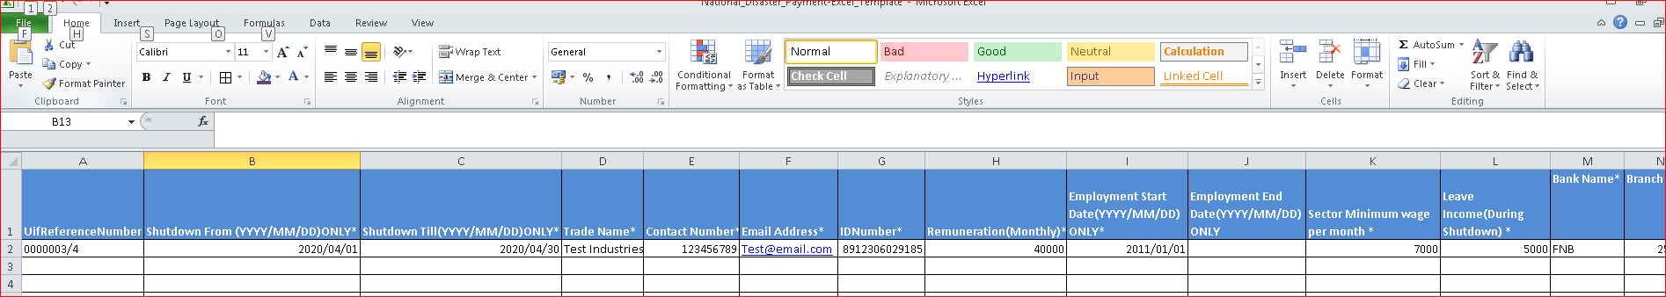

1. **Go to File (Top Left in the File) and Click Save As**

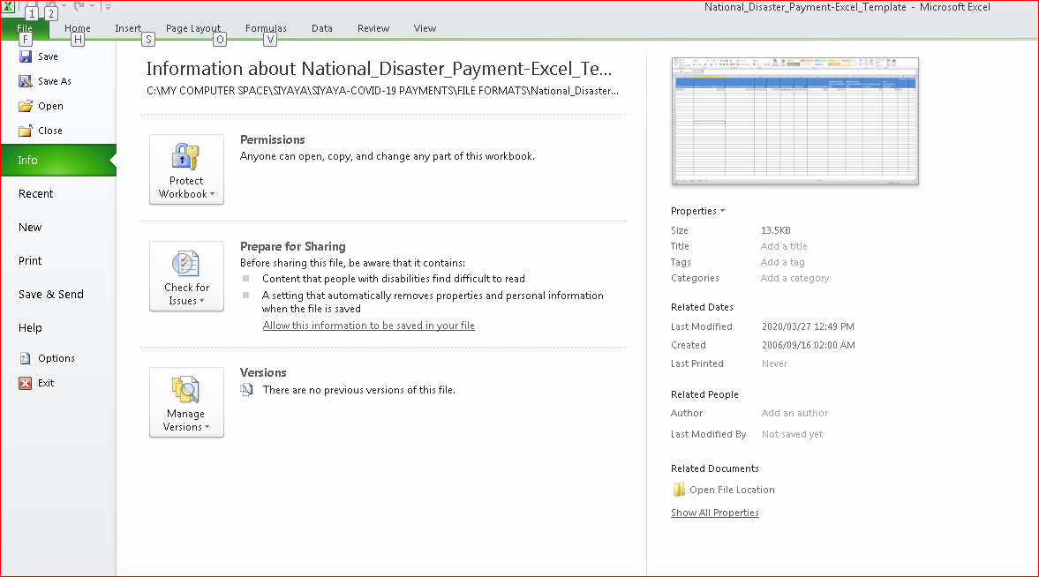

1. **Select the Save as type option dropdown and select CSV(Comma delimited). Also change the file name in the suggested format UIFreferenceNumber_DDMMYYYY_uniqueno.**

**Ex- if the uifreferencenumber is 00000012 and date of sending file is 02-04-2020 and this is the first file you are sending then use 1 as unique file number.**

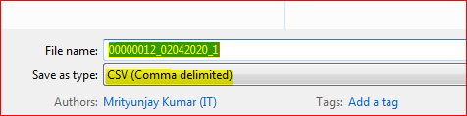

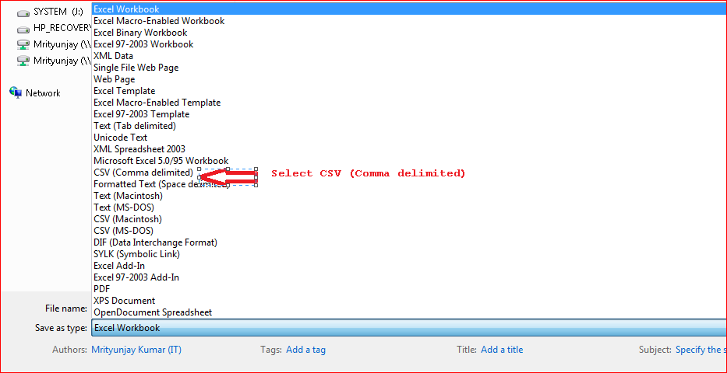

1. **On click of Save, you will be prompted with warning message – the selected file does not support workbook that contain multiple sheets. Click OK(Highlighted in yellow in the below screen)**

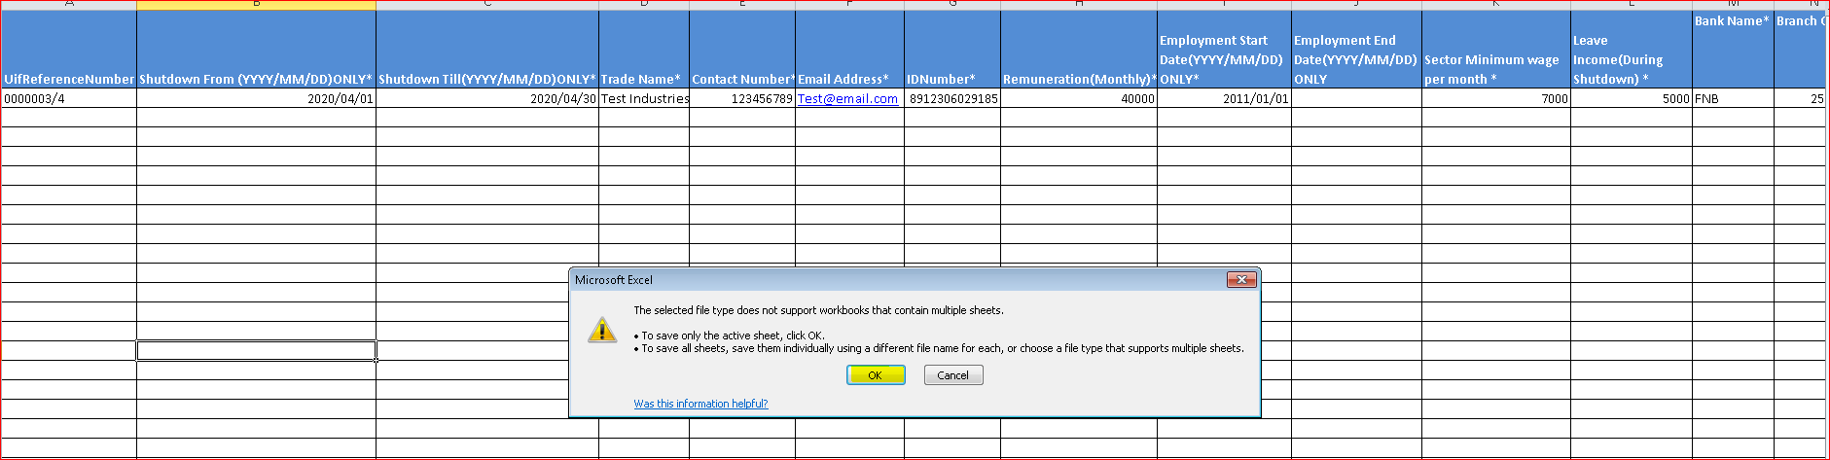

1. **You will again be prompted with another warning message that the file may contain features that are not compatible with CSV(as below screen). Click Yes button(Highlighted in Yellow)**

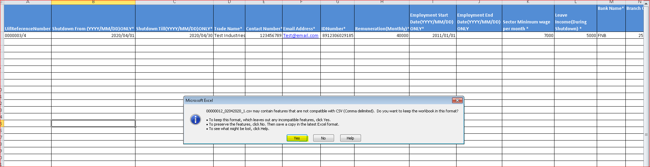

1. **The file will be save in CSV format at the location where the Excel file is located.Right Click on the file and select ‘Rename’ option.**

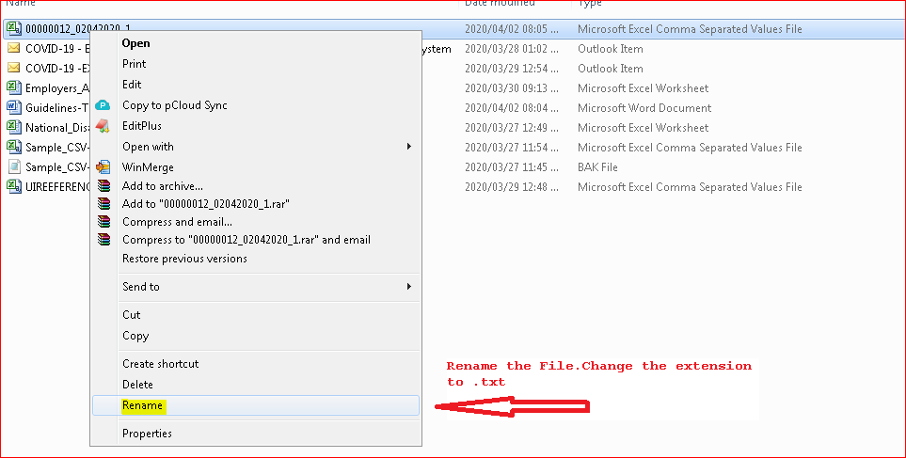

1. **Change the file extention to “.txt” and press enter button on keyboard.(see the screen below.)**



1. **Right click on the file and select Open with option to select Notepad.**

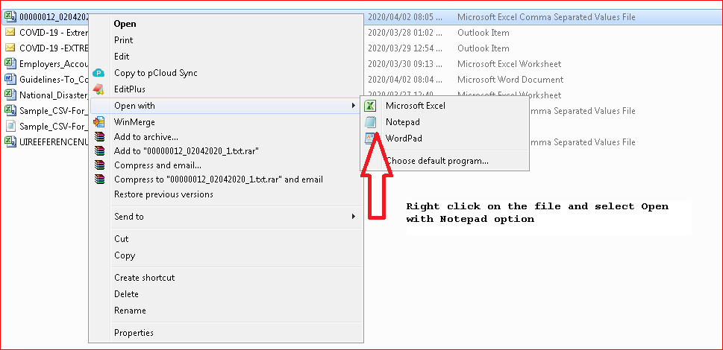

1. **The file will look like the one below with Pipe (|)delimiters. Remove the Header that represents column name. Here the first line that starts with Uifreferencenumber must be removed.**

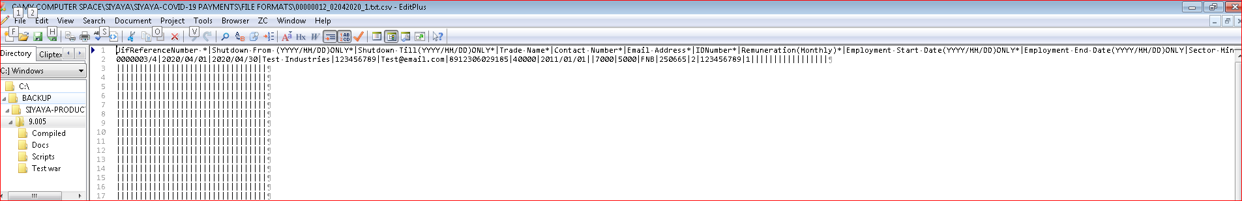

1. **Add a header on the first line as indicated below . H|Date 02Apr2020 and add a Footer at the end of the file F|Number of records in the file(as seen in the screen below).**

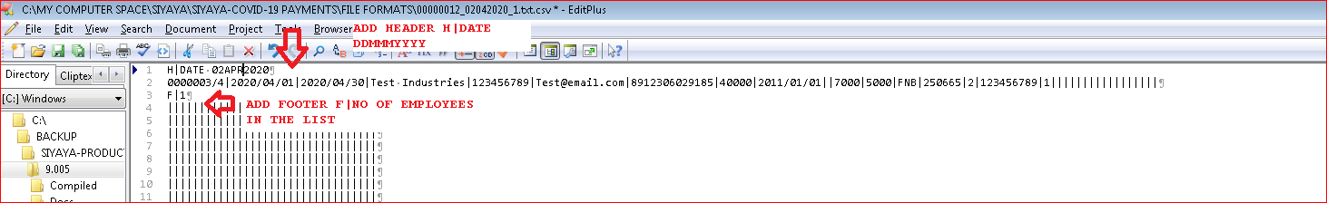

1. **Save the file using the Save option. The CSV file is ready for submission to the UIF.**